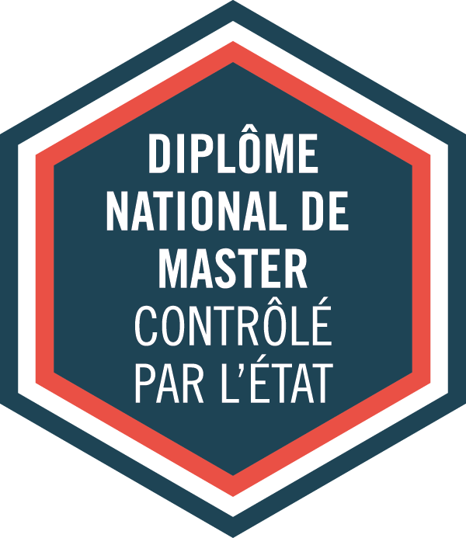

MENTION

**Droit International**

**et Droit Européen**

PARCOURS-TYPE

LL.M. International Aviation Law

60 credits - 2 semesters

Mention :

**Marc BLANQUET**

**Zoé JACQUEMIN**

*Law professors*

ADMISSION

Application online:[*http://esl.ut-capitole.fr/*](http://esl.ut-capitole.fr/)

*(Check the « Admission and registration requirements » tab)*

Année Universitaire **2025/2026**

**MASTER (2nd year)**

ACADEMIC DIRECTORS

Code RNCP: 36113

Parcours-type:

**Laurent GROSCLAUDE**,

*Law professor*

|  |
| --- |
| **USEFUL LINKS** |
| **MORE INFORMATION ON OUR PROGRAMMES:**   * *https://esl.ut-capitole.fr/formations/diplomes/* * *http://tls-droit.ut-capitole.fr/* * [*http://www.ut-capitole.fr/formations/*](http://www.ut-capitole.fr/formations/)   *_______________________________________________________________________________*  **CAREER PLANNING:**  ***Find information regarding professional choices and career planning:***   * *http://www.ut-capitole.fr/orientation-insertion/*   ***SUIO-IP online DOC:***   * *https://suio-ut-capitole.centredoc.fr/*   *______________________________________________________________________________*  **MORE INFORMATION ABOUT INTERNSHIPS:**  (Législation, convention de stage…)   * [*https://www.ut-capitole.fr/accueil/orientation-insertion/stages-entrepreneuriat-cesure*](https://www.ut-capitole.fr/accueil/orientation-insertion/stages-entrepreneuriat-cesure)   *_______________________________________________________________________________*  **OFIP’s SURVEYS ON CAREER GUIDANCE AND OCCUPATIONAL INTEGRATION:**   * [*https://www.ut-capitole.fr/repertoire-des-emplois*](https://www.ut-capitole.fr/repertoire-des-emplois)   *______________________________________________________________________________*  **DISABLED STUDENTS WELCOMING:**   * *https://www.ut-capitole.fr/handicap/* |

Distance learning

Lifelong learning

Full-time education

Block-release training

**DESCRIPTION**

Flying has become common but for most human beings it remains an incredible achievement! In spite of the Covid-19 global crisis, the aviation sector has a bright future. This crisis is a real game-changer, legitimately questioning both players and models, but it is definitely not the end of the long-lasting adventure of aviation. Air traffic is gradually resuming and private entities as well as public institutions are committed to tackling aviation’s greatest challenge: flying with net zero emissions.

Aside from environmental concerns, regional and international regulation authorities, airlines, airport operators, aircraft manufacturers, OEM, MRO and firms have to face a growing number of complex challenges and to deal with more legal and regulatory issues such as safety, security, export control, embargoes, data protection, competition, unmanned systems... In this context, the demand for qualified legal expertise is increasing.

The LLM International Aviation Law aims at offering strong expertise and appropriate solutions to aviation sector players. With over 422 hours of face-to face teaching, a set of comprehensive modules addressing the major current legal issues of this area, and many academic and industrial partnerships, this LLM stands first and unique worldwide and is designed both for graduate students and for top executives in these domains

**ACADEMIC PROGRAMME**

The LL.M. includes 422 hours of teaching and seminars divided into 2 core modules and 4 specialized modules. All modules are mandatory to obtain the Master degree. Courses are offered in sessions of three to five days, approximately once a month. Participants also have either to complete an internship or to conduct a group-work project under academic or professional supervision. Standalone modules and courses are available on demand and subject to special arrangements.

**For more informations, check RNCP (Répertoire National des Certifications Professionnelles) information sheet for « master mention droit international et droit européen »: *https://www.francecompetences.fr/recherche/rncp/36113/***

**EVALUATION**

Core module 1: a 3-hour written exam (practical case) – 15 credits

Core module 2: a 3-hour written exam (practical case) – 15 credits

Specialized modules: one oral examination encompassing all 4 modules + one in-class test per module – 20 credits

Internship or group project: written report and defense – 10 credits

**ADMISSION AND REGISTRATION REQUIREMENTS**

**TARGETED PUBLIC:**

The LLM is open to applicants:

- holding a 1st year of a Master's degree (240 ECTS)

- holding a Bachelor’s degree granted in 4 years (240 ECTS)

- holding an Engineering degree

- holding an equivalent degree in the fields of Law, Economics, Management, Engineering, Tourism...

- or having proven solid professional experience related to the aviation sector

A good command of English is mandatory (no test required).

**Selection criteria**

Application must be made through the online platform: <https://esl.zohorecruit.eu> **and** on the “Etudes en France” platform if you are living in a country or a territory affected by the “Etudes en France” procedure : <https://pastel.diplomatie.gouv.fr/etudesenfrance/dyn/public/authentification/login.html>.

A **selection interview** will take place for the pre-selected candidates in view of the sent documents.

The admission committee will assess your application based on academic results, personal experience (international and/or professional) and motivation.

Required documents for all applicants

- A copy of your passport or I.D

- A copy of diploma(s) and official transcript(s).

- A cover letter (in English)

- A curriculum vitae (in English)

- Certificate of English proficiency (not mandatory)

* IMPORTANT : Depending on your country of residence, you may have to comply with additional visa procedures. Please get in touch with the Campus France office in your home country or check at: *https://www.campusfrance.org/*

The intake capacity is set at 18 (face-to-face teaching)

Registration fees:

- Apprenticeship contract: €9,500 (Coverage by the company and its OPCO)

- Initial training: €250 for registration + €7,250 for specific fees

**ACADEMIC PROGRAMME**

|  |  |
| --- | --- |
| **SEMESTER 3** | **SEMESTER 4** |
| **CORE MODULES – 135 hours – 30 credits**  **Core module 1 – Aerospace Legal Framework – 75 hours**   * Introduction to ecosystem, challenges and international air law (8 hrs) * Private international law (15 hrs) * Dispute resolution (litigation/ADR/Arbitration) (15 hrs) * Chicago convention – ICAO (10 hrs) * Traffic rights (12 hrs) * Aviation historical and geopolitical landmarks (5 hrs) * Intellectual property in the aviation sector (10 hrs)   **Core module 2 – Aerospace economics & management – 65 hours**   * Compliance in the aviation sector (10 hrs) * Aviation economics (10 hrs) * Aerospace management (15 hrs) * Insurance issues in the air sector (10 hrs) * Sustainable development and air transport (20 hrs) | **SPECIALIZED MODULES – 282 hours – 30 credits**  **Specialized module 3 – Contracts and financing – 70 hours**   * Sale, purchase and support contracts in the aviation sector (15 hrs) * Guarantees (10 hrs) * Aircraft financing – leasing and lease-back operations (15 hrs) * Export control and Economic Sanctions (20 hrs) * Aviation and competition law (10 hrs)   **Specialized module 4 – Security – Safety – Liability – 75 hours**   * Aviation security (10 hrs) * Aviation safety and accident investigation (15 hrs) * International Aviation criminal law (10 hrs) * Carriers liability / passengers’ rights (20 hrs) * Data protection in aviation (10 hrs) * Human factors (10 hrs)   **Specialized module 5 – Air carriers – 40 hours**   * Air carriers regulations (10 hrs) * Airline cooperation (10 hrs) * Business aviation (10 hrs) * Freight transport (10 hrs)   **Specialized module 6 – Aircraft and Unmanned Aerial Vehicles (UAVs) – 40 hours**   * Drones regulatory framework (15 hrs) * Aerospace engineering (aircraft, air transport system) (15 hrs) * Airworthiness (10 hrs)   **Specialized module 7 – Airports and ground handling operations – 27 hours**   * Airport construction, ownership and management models (15 hrs) * Airport facilitation and slots management (5 hrs) * Ground handling operations (7 hrs)   **Specialized module 8 – INTERSHIP or TUTORED PROJECT – 30 hours**  Every student must complete an internship of at least three months or a tutored project.   * Methodology (18 hrs) * Apprenticeship guidance (12 hrs) |

|  |  |  |
| --- | --- | --- |
| contact DETAILS  UniversitÉ Toulouse Capitole  2 rue du Doyen Gabriel Marty  31042 Toulouse Cedex 9  **MASTER COURSES ADMINISTRATION:**  Office AR 334 Arsenal building)  Email: esl-masters@ut-capitole.fr  Tél.: 05 61 63 38 48  **ACADEMIC DIRECTOR**  **Laurent GROSCLAUDE**  Email: Laurent.grosclaude@ut-capitole.fr  Phone: 05 61 12 88 57 | Applications and Registrations:  european school of law  Office AR 334  2, rue du doyen Gabriel Marty  31042 TOULOUSE CEDEX 9  Email: [esl-admission@ut-capitole.fr](mailto:esl-admission@ut-capitole.fr)  Phone: + 33 5 61 63 38 48  EXECUTIVE EDUCATION AND DIGITAL UNIVERSITY  **EEDU**  Manufacture des Tabacs – Q building  21 allée de Brienne, 31042 Toulouse Cedex 9  Email: [executive.education@ut-capitole.fr](javascript:melA('executive.education','','','ut-capitole.fr');) | SUIO-IP  **UNIVERSITY CAREER, GUIDANCE**  **AND INFORMATION SERVICE**  Prefabs –Arsenal Parking  Email: suio-ip@ut-capitole.fr  Phone: +33 5 61 63 37 28  INTERNSHIP OFFICE  Arsenal building, 3rd floor, AR381  Email: stages@ut-capitole.fr  Phone: +33 5 61 63 37 35 |