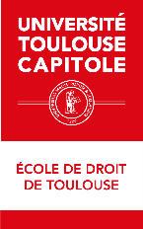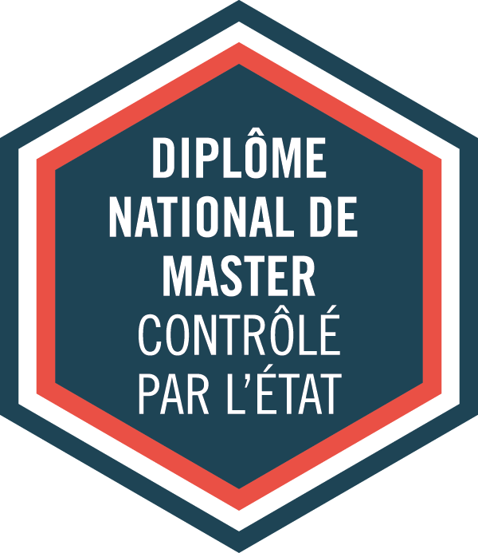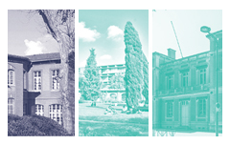

MENTION

**Droit International**

**et Droit Européen**

PARCOURS TYPE

LL.M. Cross-border Disputes (CbD)

ACADEMIC DIRECTORS:

ADMISSION

Application online: *<http://esl.ut-capitole.fr/>*

*(Check the « Admission and registration requirements » category)*

Academic Year **2025/2026**

**MASTER**

Code RNCP: 36113

120 crédits - 4semesters

Mention:

**Marc BLANQUET**,

**Zoé JACQUEMIN**,

*Law professors*

Parcours-type:

**Oana Andreea MACOVEI**,

*Law professor, 1st year*

**Estelle GALLANT**, *Law professor, 2nd year*

|  |
| --- |
| **USEFUL LINKS** |
| **MORE INFORMATION ON OUR PROGRAMMES :**   * *http://tls-droit.ut-capitole.fr/* * [*http://www.ut-capitole.fr/formations/*](http://www.ut-capitole.fr/formations/) * *https://esl.ut-capitole.fr/*   *______________________________________________*  **CAREER PLANNING:**  ***Find information regarding professional choices and career planning:***   * *http://www.ut-capitole.fr/orientation-insertion/*   ***SUIO-IP online DOC:***   * *https://suio-ut-capitole.centredoc.fr/*   *______________________________________________________________________________*  **MORE INFORMATION ABOUT INTERNSHIPS:**  (Législation, convention de stage…)   * [*https://www.ut-capitole.fr/accueil/orientation-insertion/stages-entrepreneuriat-cesure*](https://www.ut-capitole.fr/accueil/orientation-insertion/stages-entrepreneuriat-cesure)   *_______________________________________________________________________________*  **OFIP’s SURVEYS ON CAREER GUIDANCE AND OCCUPATIONAL INTEGRATION:**   * [*https://www.ut-capitole.fr/repertoire-des-emplois*](https://www.ut-capitole.fr/repertoire-des-emplois)   *______________________________________________________________________________*  **DISABLED STUDENTS WELCOMING:**   * *https://www.ut-capitole.fr/handicap/* |

Distance learning

Lifelong learning

Full-time education

Block-release training

**DESCRIPTION**

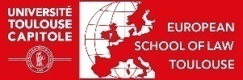

This programme covers conflict of laws principles in cross-border cases, international jurisdictions, litigation rules and arbitration with a view to providing the students with the tools needed to hold positions as lawyers in an international and European firms.

This type of programme is a rare opportunity in France providing the cross competences, reflexes, methodology and knowledge that are necessary to the internationalisation and europeanisation of private law cases and regulations. The LLM is a globally recognised degree, particularly in English-speaking countries.

**Semesters 1 and 2** aim at giving students a thorough knowledge of the private and public aspects of international and European legal issues.

The programme offers a comparative perspective, focuses on methodology with a view to providing the students with the tools needed to hold positions as lawyers in an international and European context.

**Semester 3 and 4** aim at giving students a high level of proficiency in Private International Law.

There are 2 tracks for semester 4:

- Local track (Université Toulouse Capitole)

- International Mobility track (Universiy of Dundee - 20 seats)

Students who opt for International Mobility will thus obtain both a French Master's diploma and the LL.M. (Latin Legum Magister) under two cumulative conditions: the validation of semester 3 in Toulouse and the mandatory semester 4 in Dundee. The LLM certificate is awarded during a graduation ceremony at the University of Dundee.

Students who opt for Local track will obtain the French Master's diploma only.

**SKILLS AND TARGETED OCCUPATIONS**

**Skills:**

The teachings during the entire Program pave the way to European and international

careers, or employment requiring to manage different situations connected with international and European law. Students are encouraged to develop initiatives in order to bring out skills in organisation, communication and exchanges, which are essential for any legal practitioner who works in a team, with potential partners from all around the world, international organisations, firms or universities. The exchange during the second semester is a chance for developing the abilities of adaptation and communication in an international context.

**CAREERS:**

Professional opportunities are:

* Lawyer practise – National or international private litigation
* Legal departments in French or foreign private, public or public-private companies.
* Domestic or International/European Civil service
* NGOs.
* Assistance and expert assessment for international institutions or national institutions
* Academic career in France or abroad.

**For more informations, check RNCP (Répertoire National des Certifications Professionnelles) information sheet for « master mention droit international et droit européen »: *https://www.francecompetences.fr/recherche/rncp/36113/***

**ACCESS TO THE FIRST YEAR OF THE MASTER**

**Selection criteria:**

The admission committee will assess your application based on academic results, English proficiency, personal experiences (international and/or professional) and motivation.

**According to your country of residence, you may have to comply with additional visa procedures. Please get in touch with the Campus France office in your home country or check at:** ***https://www.campusfrance.org***

**Admission criteria:**

A three-year degree in law is required, equivalent to 180 ECTS (European credits) i.e. Bachelor’s degree, Licence or equivalent. Other qualifications and area of study may be considered by the Admission Committee.

Students must have an adequate command of the English language to enrol. An applicant's English proficiency level may be demonstrated by means of score reports of recognized exams, tests or certificates (equivalent to C1 level of the Common European Framework of Reference for Languages) or by any relevant means (study and life experience in a program taught in English…)

**Application procedure:**

Application must be made through the online platform: <https://esl.zohorecruit.eu> **and** on the “Etudes en France” platform if you are living in a country or a territory affected by the “Etudes en France” procedure : <https://pastel.diplomatie.gouv.fr/etudesenfrance/dyn/public/authentification/login.html>.

A selection interview will take place for the pre-selected candidates in view of the sent documents.

The exhaustive list of documents needed as well as the procedure's exact details will be given at the time of application.

The intake capacity is set at 25 places in the 1st year of the CbD course (face-to-face teaching)

**Registration fees:**

€ 4,500 for the academic year 2025-2026, regardless of the candidate's nationality.

**ACCESS TO THE SECOND YEAR OF THE MASTER**

**Selection criteria:**

The admission committee will assess your application based on academic results, English proficiency, personal experiences (international and/or professional) and motivation.

**According to your country of residence, you may have to comply with additional visa procedures. Please get in touch with the Campus France office in your home country or check at:** [***https://www.campusfrance.org.***](https://www.campusfrance.org.)

**Admission criteria:**

A four-year degree in law is required, equivalent to 240 ECTS (European credits) and preferably specialised in international and european legal issues, but not exclusively. Other qualifications and area of study may be considered by the admission committee.

Students must have an adequate command of the English language to enrol. An applicant's English proficiency level may be demonstrated by means of score reports of recognized exams, tests or certificates (equivalent to C1 level of the Common European Framework of Reference for Languages) or by any relevant means (study and life experience in a program taught in English…)

**Application procedure:**

Application must be made through the online platform: <https://esl.zohorecruit.eu> **and** on the “Etudes en France” platform if you are living in a country or a territory affected by the “Etudes en France” procedure : <https://pastel.diplomatie.gouv.fr/etudesenfrance/dyn/public/authentification/login.html>.

A selection interview will take place for the pre-selected candidates in view of the sent documents.

The intake capacity is set at 28 places in the 2nd year of the CbD course (face-to-face teaching).

**Registration fees for students in Toulouse:**

€ 4,500 for the academic year 2025-2026, regardless of the candidate's nationality.

**Registration fees for students in Dundee:**

About £ 6000 (Tuition fees of 5800 £ to be paid at the University of Dundee and tuition fees of €250 to be paid at Université Toulouse Capitole)

**ACADEMIC PROGRAMME**

The first three semesters are spent at UT Capitole. During the fourth semester, students have the opportunity to study at the University of Dundee or stay at UT Capitole.

**The 1st year Master's course takes place over a period of 10 months and includes a total of 500 hours of teaching.**

|  |  |
| --- | --- |
| **SEMESTER 1 – 30 ECTS – 243 hrs** | **SEMESTER 2 – 30 ECTS – 258 hrs** |
| **UE1: European and Comparative Law -** 90hrs – 12 ECTS  Introduction to EU law  European Fundamental Rights  Introduction to Legal Systems  **UE2: International law** - 90hrs – 12 ECTS  Public International Law  Private International Law  International Criminal Law  **UE3: Legal Culture -** 45hrs – 3 ECTS  Conferences on Legal Cultures  French and European Culture and Civilization  **UE4: Skills** - 18hrs – 3 ECTS  Legal research Methodology  Language: Intensive English or French | **UE5: European Union Substantive Law -** 90hrs – 12 ECTS  Internal Market  Competition Law  EU External Relations  **UE6: Transnational law** - 90hrs - 12 ECTS  International Dispute Resolution (Public and Private)  Collaborative Transnational Learning Experience  Intellectual and Industrial Property Law  **UE7: Legal Culture** – 60hrs – 3 ECTS  Conferences on Legal Culture  French and European Culture and Civilization  **UE8: Skills** - 18hrs – 3 ECTS  Legal research Methodology  Language: Intensive English or French |

**The training course in the 2nd year of the Master's programme takes place over a period of 12 months and comprises a total of 202 hours of teaching.**

|  |  |
| --- | --- |
| **SEMESTER 3 – 30 ECTS – 156 hrs** | **SEMESTER 4 – 30 ECTS -- TOULOUSE OR DUNDEE** |
| **UE1: Cross-border Litigation -** 51hrs – 9 ECTS  Advanced Private International Law  Advanced European Private International Law  Arbitration and Alternative Dispute Resolution  EPIL and PIL news  **UE2: Private Law in a Global Context** - 60hrs – 15 ECTS  International Trade Law  International Sale of Goods  Private International Family and Property Law  International Social and Labour Law  International Insolvency Law  **UE3: Global Challenges -** 27hrs – 6 ECTS  *Choose 3 courses from the 6 offered :*  Anti-corruption Law - OECD  International Harmonization of Private Law – UNIDROIT  International Tax Law  Outer Space Law  Economic Aspects of EU Integration  Aviation Law  **UE4: Skills** - 18hrs  Empiric research Methodology  Language: Intensive English or French | **LOCAL TRACK IN TOULOUSE – 46 hrs**  **UE5: Cross-border Transactions -** 36hrs – 9 ECTS  Digital Governance  Data Protection  E-Commerce  **UE6: ESL Legal Lab** - 10hrs - 6 ECTS  **UE7: Internship or Dissertation (choose one)**  - 15 ECTS  **INTERNATIONAL MOBILITY TRACK IN DUNDEE**  **Module 5**  University of Dundee proposes mandatory courses (Unit 1) and optional courses (Unit 2&3).  *Optional courses can vary from a year to an other.*  Students could pick :  - 2 courses of Unit 2 OR  - 1 course of Unit 2 and 1 course of Unit 3  *Here is the list of courses per Unit:*  **UNIT 1:**  - PIL  - Legal Research Skills  - Master Dissertation  **UNIT 2:**  - Competition Law  - International Taxation Law  - International Energy Arbitration: Practical Exercises  - The Law of Mergers and Acquisitions  - Privacy, Cybersecurity and Surveillance  - International Dispute Resolution  - International Law and Energy Disputes  **UNIT 3:**  -Water Law  - International Dispute Resolution  - Human Rights in International Relations  - International Energy Arbitration: Practical Exercises  - Digital Evidence  - Business and Human Rights  - Private International Law (Common Law Perspectives)  - Competition Law  - World Trade Organisation Law  - International Taxation Law  - National and Comparative Oil and Gas Law  - Transnational Law of Sustainable Development and Environment  - International Relations and Energy and Natural Resources  - Mineral and Petroleum Taxation  - Political Economy of Climate Change and the Environment  - Privacy, Cyber Security and Surveillance  - Corporate Sustainability and ESG Law  - The Law of Mergers and Acquisitions  **Module 6 - LL.M thesis**  The student must write a research thesis in English. The topics will be chosen from a list established by the University of Dundee in association with UT Capitole. This thesis has to be submitted by August according to the examination rules at the University of Dundee (no oral defence is required).  A professional internship is still possible but optional. |

|  |  |  |
| --- | --- | --- |
| contact DETAILS  UniversitY Toulouse capitole  2 rue du Doyen Gabriel Marty  31042 Toulouse Cedex 9  **MASTER COURSES ADMINISTRATION :**  **Office AR 334**  **Courriel :**  esl-masters@ut-capitole.fr  **Tél. :** 05 61 63 39 26 | Applications and Registrations :  european school of law  Office AR 334  2, rue du doyen Gabriel Marty  31042 TOULOUSE CEDEX 9  Mail : [esl-admission@ut-capitole.fr](mailto:esl-admission@ut-capitole.fr)  Phone : + 33 5 61 63 38 84 | SUIO-IP  **UNIVERSITY CAREER, GUIDANCE**  **AND INFORMATION SERVICE**  Prefabs –Arsenal Parking  Mail : suio-ip@ut-capitole.fr  Phone: +33 5 61 63 37 28  INTERNSHIP OFFICE  Arsenal building, 3rd floor, AR381  Mail : stages@ut-capitole.fr  Phone : +33 5 61 63 37 35 / 35 18 |