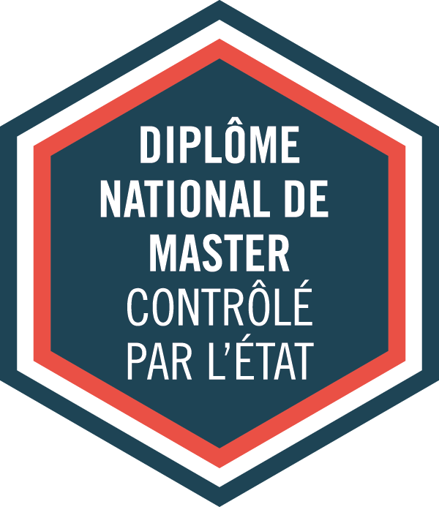

MENTION

**Droit International**

**et Droit Européen**

PARCOURS-TYPE

LL.M. International Economic Law (IEL)

ACADEMIC DIRECTORS :

ADMISSION

Application online: *<http://esl.ut-capitole.fr/>*

*(Look at the « Admission and registration requirements » category)*

**MASTER**

Academic year **2025-2026**

120 crédits - 4semesters

Code RNCP : 36113

Mention :

**Marc BLANQUET**,

**Zoé JACQUEMIN**,

*Law professors*

Parcours-type :

**Oana MACOVEI**,

*Law Professor (1st year)*

**Clémentine BORIES, Philippe GOUT**,

*Law Professors (2nd year)*

|  |
| --- |
| **USEFUL LINKS** |
| **MORE INFORMATION ON OUR PROGRAMMES :**   * *http://tls-droit.ut-capitole.fr/* * [*http://www.ut-capitole.fr/formations/*](http://www.ut-capitole.fr/formations/) * *https://esl.ut-capitole.fr/*   *______________________________________________________________________________*  **CAREER PLANNING:**  ***Find information regarding professional choices and career planning:***   * *http://www.ut-capitole.fr/orientation-insertion/*   ***SUIO-IP online DOC:***   * *https://suio-ut-capitole.centredoc.fr/*   *______________________________________________________________________________*  **MORE INFORMATION ABOUT INTERNSHIPS:**  (Législation, convention de stage…)   * [*https://www.ut-capitole.fr/accueil/orientation-insertion/stages-entrepreneuriat-cesure*](https://www.ut-capitole.fr/accueil/orientation-insertion/stages-entrepreneuriat-cesure)   *______________________________________________________________________________*  **OFIP’s SURVEYS ON CAREER GUIDANCE AND OCCUPATIONAL INTEGRATION:**   * [*https://www.ut-capitole.fr/repertoire-des-emplois*](https://www.ut-capitole.fr/repertoire-des-emplois)   *______________________________________________________________________________*  **DISABLED STUDENTS WELCOMING:**   * *https://www.ut-capitole.fr/handicap/* |

Distance learning

Lifelong learning

Full-time education

Block-release training

**DESCRIPTION**

The program focuses mainly on the study of the World Trade Organization, of the European Union in an economic perspective and of international economic development. The Master/LL.M. IEL also aims at providing students with some basic knowledge of international law, contracts and market regulation.

**Semesters 1 and 2** aim at giving students a thorough knowledge of the private and public aspects of international and European legal issues. The programme offers a comparative perspective, focuses on methodology with a view to providing the students with the tools needed to hold positions as lawyers in an international and European context.

**Semesters 3 and 4** aim at giving students a thorough knowledge of international economic legal issues. According to the French grading system, the master’s degree is a national diploma recognised in the European Union countries and which is equivalent to a Legum Magister (LL.M.).

**The two semesters are composed of mandatory courses**.

Two tracks are available: The Research track and the Professional track.

**Students opting for the Research track** must write a master’s thesis. When the programme is successfully completed, students who have chosen this track may apply for a PhD.

**Students opting for the Professional track** must do an internship (minimum 2 months eq. 308 hrs) and write a report.

**SKILLS AND TARGETED OCCUPATIONS**

**Ski**l**ls:**

Occupational integration preparation, legal document drafting, plea and counselling simulations.

**For more informations, check RNCP (Répertoire National des Certifications Professionnelles) information sheet for « master mention droit international et droit européen »: *https://www.francecompetences.fr/recherche/rncp/36113/***

**Targeted occupations:**

Students who obtain the IEL have several legal job opportunities, and especially those in relation with international economic law. The programme provides them with the skills needed to hold positions in law firms, companies but also in public services, including international or European institutions. Students opting for the Research Track can pursue academic research.

**ACCESS TO THE FIRST YEAR OF THE MASTER**

**Selection criteria:**

The admission committee will assess your application based on academic results, English proficiency, personal experiences (international and/or professional) and motivation.

**According to your country of residence, you may have to comply with additional visa procedures. Please get in touch with the Campus France office in your home country or check at:** ***https://www.campusfrance.org***

**Admission criteria:**

A three-year degree in law is required, equivalent to 180 ECTS (European credits) i.e. Bachelor’s degree, Licence or equivalent. Other qualifications and area of study may be considered by the Admission Committee.

Students must have an adequate command of the English language to enrol. An applicant's English proficiency level may be demonstrated by means of score reports of recognized exams, tests or certificates (equivalent to C1 level of the Common European Framework of Reference for Languages) or by any relevant means (study and life experience in a program taught in English…)

**Application procedure:**

Application must be made through the online platform: <https://esl.zohorecruit.eu> **and** on the “Etudes en France” platform if you are living in a country or a territory affected by the “Etudes en France” procedure : <https://pastel.diplomatie.gouv.fr/etudesenfrance/dyn/public/authentification/login.html>.

A selection interview will take place for the pre-selected candidates in view of the sent documents.

The intake capacity is set at 25 places in the 1st year of the IEL course (face-to-face teaching)

**Registration fees:**

€ 4,500 for the academic year 2025-2026, regardless of the candidate's nationality.

**ACCESS TO THE SECOND YEAR OF THE MASTER**

**Selection criteria:**

The admission committee will assess your application based on academic results, English proficiency, personal experiences (international and/or professional) and motivation.

**According to your country of residence, you may have to comply with additional visa procedures. Please get in touch with the Campus France office in your home country or check at:** [***https://www.campusfrance.org.***](https://www.campusfrance.org.)

**Admission criteria:**

A four-year degree in law is required, equivalent to 240 ECTS (European credits) and preferably specialised in international and european legal issues, but not exclusively. Other qualifications and area of study may be considered by the admission committee.

Students must have an adequate command of the English language to enrol. An applicant's English proficiency level may be demonstrated by means of score reports of recognized exams, tests or certificates (equivalent to C1 level of the Common European Framework of Reference for Languages) or by any relevant means (study and life experience in a program taught in English…)

**Application procedure:**

Application must be made through the online platform: <https://esl.zohorecruit.eu> **and** on the “Etudes en France” platform if you are living in a country or a territory affected by the “Etudes en France” procedure : <https://pastel.diplomatie.gouv.fr/etudesenfrance/dyn/public/authentification/login.html>.

A selection interview will take place for the pre-selected candidates in view of the sent documents.

The intake capacity is set at 28 places in the 2nd year of the IEL course (face-to-face teaching)

**Registration fees:**

€ 4,500 for the academic year 2025-2026, regardless of the candidate's nationality.

**A Dual degree Master International and Economic Law – LL.M. with Stetson University (USA, FL) in second year with will be offered to 2 students from 1st year.** The application campaign for the dual degree with Stetson University is scheduled every year in Semester 2.

**ACADEMIC PROGRAMME**

**The 1st year Master's course takes place over a period of 10 months and includes a total of 500 hours of teaching.**

|  |  |
| --- | --- |
| **SEMESTER 1 – 30 ECTS – 243 hrs** | **SEMESTER 2 – 30 ECTS – 258 hrs** |
| **UE1: European and Comparative Law -** 90hrs – 12 ECTS  Introduction to EU law  European Fundamental Rights  Introduction to Legal Systems  **UE2: International law** - 90hrs – 12 ECTS  Public International Law  Private International Law  International Criminal Law  **UE3: Legal Culture -** 45hrs – 3 ECTS  Conferences on Legal Cultures  French and European Culture and Civilization  **UE4: Skills** - 18hrs – 3 ECTS  Legal research Methodology  Language: Intensive English or French | **UE5: European Union Substantive Law -** 90hrs – 12 ECTS  Internal Market  Competition Law  EU External Relations  **UE6: Transnational law** - 90hrs - 12 ECTS  International Dispute Resolution (Public and Private)  Collaborative Transnational Learning Experience  Intellectual and Industrial Property Law  **UE7: Legal Culture** – 60hrs – 3 ECTS  Conferences on Legal Culture  French and European Culture and Civilization  **UE8: Skills** - 18hrs – 3 ECTS  Legal research Methodology  Language: Intensive English or French |

**The training course in the 2nd year of the Master's programme takes place over a period of 12 months and comprises a total of 184 hours of teaching.**

|  |  |
| --- | --- |
| **SEMESTER 3 – 30 ECTS – 138 hrs** | **SEMESTER 4 – 30 ECTS – 46 hrs** |
| **UE1: Fundamental International Economic Law -** 75hrs – 15 ECTS  International Company Law  International Financial Law  International Investment Law and Investor – State Dispute Settlement  International Trade Law  International Litigation and Arbitration  **UE2: Sustainable Economy** - 24hrs – 9 ECTS  International Sustainable Development Law  The Future of Work – Signature Course ENGAGE.EU Alliance  Common Goods  **UE3: Global Challenges -** 27hrs – 6 ECTS  *Choose 3 courses from the 6 offered :*  Anti-corruption Law - OECD  International Harmonization of Private Law – UNIDROIT  International Tax Law  Outer Space Law  Economic Aspects of EU Integration  Aviation Law  **UE4: Skills** - 18hrs  Empiric research Methodology  Language: Intensive English or French | **UE5: Digital Economy -** 36hrs – 9 ECTS  Digital Governance  Data Protection  E-Commerce  **UE6: ESL Legal Lab** - 10hrs - 6 ECTS  **UE7: Internship or Dissertation (choose one)** – 15 ECTS |
| **INTERNATIONAL MOBILITY IN STETSON (FL, USA)** | |
| This program mainly deals with international economic law and international law.  The student will spend the entire semesters 3 & 4 at Stetson University College of Law.  The student must complete all the required courses and pass the exams according to the host University requirements. As for the elective courses, they must be chosen upon approval of the University of Toulouse Capitole. All the exam modalities at Stetson University College of Law are handled by the host university. More information about the [curriculum](http://www.stetson.edu/law/international/llm/international-law-llm-curriculum.php) : https://www.stetson.edu/law/international/llm/international-law-llm-curriculum.php.  In addition, to validate the LLM IEL Program the student must either write and defend a master's thesis or write a report based on an internship experience (Duration 2 months or 308hours). | |

|  |  |  |
| --- | --- | --- |
| contact DETAILS  UniversitY Toulouse capitole  2 rue du Doyen Gabriel Marty  31042 Toulouse Cedex 9  **MASTER COURSES ADMINISTRATION :**  **Office AR 334**  **Courriel :**  esl-masters@ut-capitole.fr  **Tél. :** 05 61 63 39 26 | Applications and Registrations :  european school of law  Office AR 334 (Arsenal building)  2, rue du doyen Gabriel Marty  31042 TOULOUSE CEDEX 9  **Mail :** [esl-admission@ut-capitole.fr](mailto:esl-admission@ut-capitole.fr)  **Phone :** + 33 5 61 63 38 84 | SUIO-IP  **UNIVERSITY CAREER, GUIDANCE**  **AND INFORMATION SERVICE**  Prefabs –Arsenal Parking  Mail : suio-ip@ut-capitole.fr  Phone: +33 5 61 63 37 28  INTERNSHIP OFFICE  Arsenal building, 3rd floor, AR381  Mail : stages@ut-capitole.fr  Phone : +33 5 61 63 37 35 / 35 18 |